|  |  |  |
| --- | --- | --- |
| Plant | Dectes tunnel? | # of larvae |
| 1 |  |  |
| 2 |  |  |
| 3 |  |  |
| 4 |  |  |
| 5 |  |  |
| 6 |  |  |
| 7 |  |  |
| 8 |  |  |
| 9 |  |  |
| 10 |  |  |
| 11 |  |  |
| 12 |  |  |
| 13 |  |  |
| 14 |  |  |
| 15 |  |  |
| 16 |  |  |
| 17 |  |  |
| 18 |  |  |
| 19 |  |  |
| 20 |  |  |
| 21 |  |  |
| 22 |  |  |
| 23 |  |  |
| 24 |  |  |
| 25 |  |  |

Date of field sampling: ________________

Field Name: ________________________

County: ____________________________

GPS: ______________________________

Growth stage: ______________________

Variety: ___________________________

Tillage: ____________________________

Previous crop: ______________________

History of dectes issues? ______________

___________________________________

___________________________________

Equipment: pocket knife or pruning shears

Procedure: Begin sampling at R6 or later. At each of 5 separate areas of the field, inspect 5 plants for dectes stem borer tunneling and larvae, for a total of 25 plants per field. For each plant sampled, split the main stem in half and examine it for dectes stem borer larvae and their tunneling. For each plant, indicate whether dectes tunneling (see attached scouting guide) is present and how many larvae are present. (Typically the number of larvae will be 0, 1, or 2).

Dectes stem borer identification

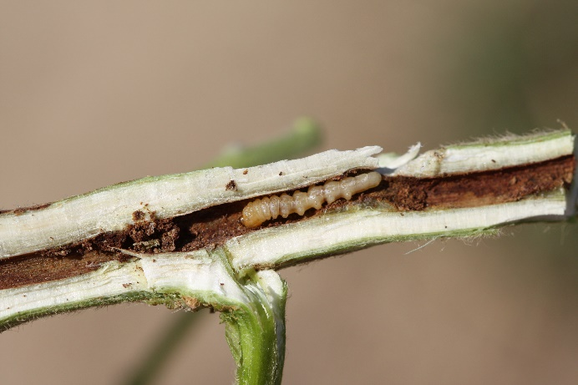

Dectes stem borer larva within a soybean stem; note tunnel lined with brown frass (Photo: Scott Stewart, University of Tennessee

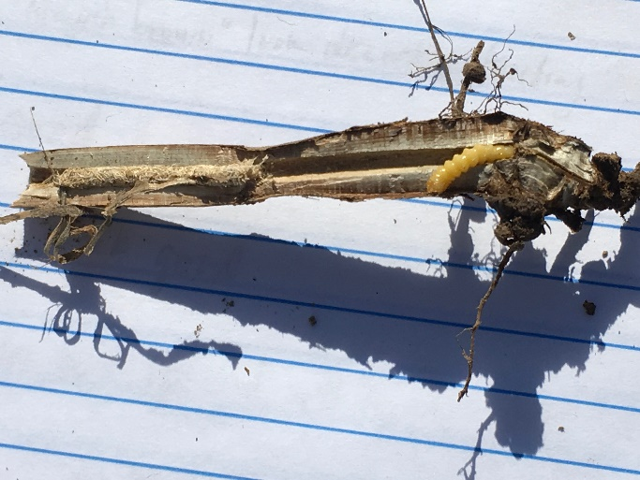

Dectes stem borer larva in base of mature, girdled soybean stem (Photo: Eric Allinger)

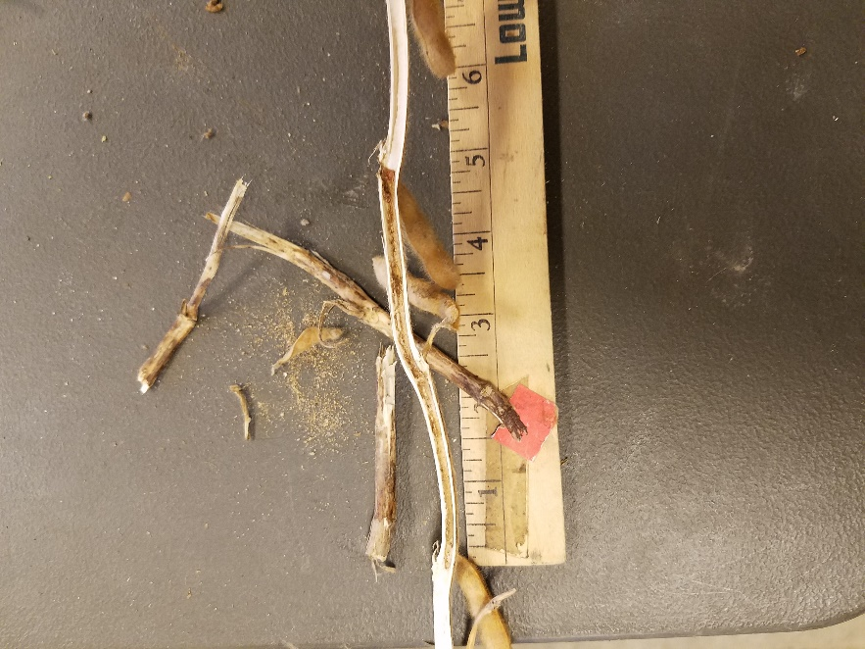

Dectes stem borer tunnel without larva in a mature soybean stem

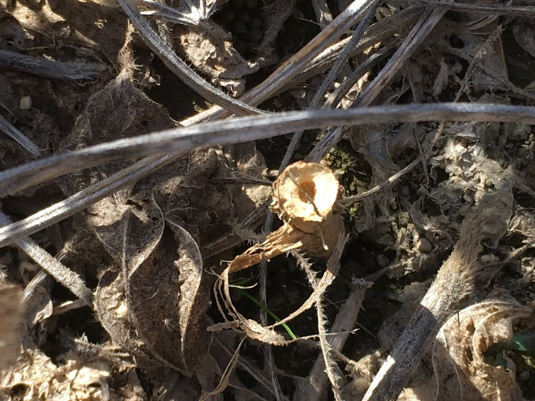

Soybean stem girdled by dectes stem borer (Photo: Eric Allinger)

Note:

* Dectes stem borer tunneling will be completely hollowed out and lined with brown “frass,” the insect’s excrement
* By September, most dectes tunneling will have reached the lower half of the soybean stem if the larva is still alive
* Generally speaking, if part of the soybean stem is narrow, tender, and difficult to split open, it is unlikely to have been tunneled